

**Asia Pacific College**

School of Computing and Information Technologies

**Escalation Straight-Up:**

**HOTEL ESCALATION MANAGEMENT MODULE   
FOR TAAL VISTA HOTEL**

By

Matthew Arnold Alabado

Alanis Watz Alconcel

Samantha Nicole Balubal

Rachel Anne Brillantes

Kathrine Danielle Burton

Engel-Jan Pamittan

January 3, 2018

Table of Contents

List of Figures, Tables and Notations i

I. Introduction 1

A. Project Context 1

B. Purpose and Description 1

C. Objectives 2

1. General Objective 2

2. Specific Objectives 2

D. Scope 3

E. Limitations 3

II. Review of Related Literature/Systems 4

A. Related Literature 4

B. Related Systems 4

III. Technical Background 8

A. Programming Language 8

B. Resource Requirements 8

IV. Methodology, Results, and Discussion for Proposed System 11

A. Requirements Analysis 11

B. Systems Overview 11

C. Use Case 12

D. Process Specification 15

1. Context Flow Diagram 15

2. Data Flow Diagram 16

E. Data Specification 18

1. Entity Relationship Diagram 18

2. Data Dictionary 19

F. Gap Analysis 23

G. Methodology 23

H. Other Graphical Representation 24

1. Class Diagram 24

2. Object Diagram 25

3. Package Diagram 25

4. Activity Diagram 26

5. State Machine Diagram 28

6. Sequence Diagram 29

7. Communication Diagram 30

8. Component Diagram 30

9. Deployment Diagram 31

10. Interaction Diagram 32

References 33

# List of Figures, Tables and Notations

Figure 1. Event Table 15

Figure 2. Use Case Diagram 16

Figure 3. Context Flow Diagram 19

Figure 4. Data Flow Diagram (Level 0) 20

Figure 5. Level 1 of Process 2 21

Figure 6. Level 2 of Process 2.4 21

Figure 7. Level 1 of Process 3 21

Figure 8. Level 1 of Process 6 22

Figure 9. Entity Relationship Diagram (ERD) 22

Figure 10. DD for Employee and Position Table 23

Figure 11. DD for Escalation Ticket History Table 23

Figure 12. Department; Hierarchy Level; Room 24

Figure 13. DD for Escalated Ticket 24

Figure 14. DD for User Table 25

Figure 15. DD for Ticket Type 25

Figure 16. DD for Ticket 26

Figure 17. Class Diagram 28

Figure 18. Object Diagram 29

Figure 19. Package Diagram 29

Figure 20. Activity for SRRS-HEMM-Senior Employee 30

Figure 21. Activity for HEMM and Executive Management 31

Figure 22. State Diagram 32

Figure 23. Sequence Diagram 33

Figure 24. Communication Diagram 34

Figure 25. Component Diagram 34

Figure 26. Deployment Diagram 35

Figure 27. Interaction Diagram 36

Table 1. Related Systems Common and Unique Features 9

Table 2. Fully-Dressed Use Case 01 17

Table 3. Fully-Dressed Use Case 02 17

Table 4. Fully-Dressed Use Case 03 18

Table 5. Gap Analysis 27

# Introduction

## Project Context

Escalation is a process used to transfer the responsibility of performing a task to another employee who is often of higher rank or position. It is also a process to re-prioritize the level of certain service requests or tasks that need immediate action.

The client, Taal Vista Hotel considers a service request to be escalated if it was unattended or not acted upon by the promised time given by the hotel employee. To improve their service to their customers, Taal Vista Hotel gives utmost importance to the customers’ request, let alone the ones that escalate frequently. The upper management is not aware if there are unattended services unless the customer comes up to the front desk and demands to see the manager. This is because the current escalation process included in Taal Vista Hotel is limited to just directly reporting it to the immediate supervisor with no documentation.

The team’s proposed solution is to create an Escalation Management Module that will be able to gather escalation data, assess employees’ capability to finish a task, and generate escalation reports that will help the Executive Managers improve the quality of services to their customers which will eventually decrease the number of escalated service requests.

## Purpose and Description

This module will track escalated service tickets, monitor ticket status and current escalation level, and send a notification to the next senior employee regarding an escalated service. There are four (4) levels of employees to whom the ticket will escalate to: Level 1 – Supervisor whose role is to deal with the hotel staff, Level 2 – Department Manager whose role is to deal with the head of the concerned management such as the resident manager or the general manager, Level 3 – Resident Manager whose role is to assist and report to the general manager of the hotel, or Level 4 – General Manager as the overall in-charge on running the hotel.

The escalation of a service request to the next senior employee will be based on the Service Level Agreement (SLA), as a standard by the hotel to finish a certain request. Notifications will be sent to the assigned employees through a mobile application. The notification will be about the task needed to be done and the responsibility to close the ticket.

Escalation reports that are generated by the module contain the details of the escalated service, the reason why it escalated, the number of times it escalated, and the details of the assigned employee. The reports will give the executive managers the information on why certain services are not met. Also, the information that will be reported by the employee from the escalation process can help identify reasons as to why some tasks are frequently unattended by their staff. The monthly or yearly escalation reports will help the Executive Managers formulate a forecast. The forecast will be used in the decision making of the managers on what precautionary actions are needed to be performed at a given time or season. The reports will lessen the possibility of services from escalating in the future and eventually have a solution to avoid the occurrence of escalated service requests.

## Objectives

### General Objective

Develop a solution for Taal Vista Hotel that will produce effective Escalation Reports from the gathered escalation data.

### Specific Objectives

* Develop an Escalation Management Module that has a seamless connection with the Service Request and Report System.
* Gather escalation data starting from the escalation of a service ticket until the ticket is closed.
* Formulate a forecast based on Escalation Reports and eventually decrease the number of escalations that occur within a month.

## Scope

* The module will begin its process once a trigger is activated by an escalated service ticket from the Service Request and Report System or receptionist.
* The module will generate escalation reports based on the escalation process of unattended services.
* The main users of the module are the Supervisor (Level 1 Employee), Department Manager (Level 2 Employee), Resident Manager (Level 3 Employee), General Manager (Level 4 Employee) of the Housekeeping and Engineering Department.

## Limitations

* The Escalation Management Module focuses on the assignment of tasks
* The project is limited on the quality aspect of services in Taal Vista Hotel.
* The escalation process is limited when the action needed on the service-related requests must be done by the expertise of a third party.

# Review of Related Literature/Systems

## Related Literature

* Escalation Management as The Necessary Form of Incident Management Process

Escalation Management is widely used for Information Technology Service Management and helps to ensure that unresolved problems do not linger, and issues are promptly addressed. It states that the existence of escalation management can re-prioritize, re-assign, and monitor to a satisfactory completion. (Peter, 2014)

The study shows how escalation management is widely accepted and used in IT Infrastructure Library (ITIL). It is also suggested and recommended to have such module to improve efficiency in service management and customer satisfaction.

## Related Systems

|  |  |  |
| --- | --- | --- |
| **SYSTEM NAME** | **COMMON FEATURES** | **UNIQUE FEATURES** |
| KNOWCROSS (KNOW Glitch) | * Real-Time Communication | * Hotel Management Software |
| HOTELTAP | * Real-Time Communication | * Analytic Dashboards * Mobile notification for instant communication among employees |
| FCS COMPUTER SYSTEMS  (Guest Services) | * Mobile-Enabled * Task Escalation | * Smart Escalation |
| ALICE (STAFF) | * Mobile-Enabled * Ticketing System * Task-Tracking System | * Accessible to-do-list through mobile * Assignment of tickets * Displays ticket status and owner * Simple User Interface |
| GESS (Guest Experience Software System) | * Task Escalation | * Automatic alert that notifies the employees |
| HOTELMGR | * Mobile-Enabled * Task-Tracking System | * Request Prioritization |
| ORACLE ESCALATION MANAGEMENT | * Task-Tracking System | * Service Request and Task-Linking Capability * Ownership assignment * De-escalation & closure * Automatic notification (Escalation Progress) |
| Escalation Straight-Up | * Mobile-Enabled * Task Escalation * Assignment of tickets | * Notification alert * Hierarchy level of senior employees for escalation process of the unattended tickets |

Table 1. Related Systems Common and Unique Features

* KNOWCROSS

One feature of KNOWCROSS which is called KNOW GLITCH that allows the hotel to track the issues in real-time. The real-time tracking of issues gives an advantage to the hotel to gain satisfaction from customers and accommodate more loyal customers by giving proper action to the issues. *(KNOW Glitch . (n.d.). Retrieved from KNOWCROSS: http://www.knowcross.com/know-glitch/)*

* HOTELTAP

HotelTap is an application which helps the guests’ meet their expectations with communication, task completion, and maintenance.

HotelTap is accessible through mobile application that notifies employee that will allow the hotel employee for instant communication It also has Analytics Dashboard that shows a graphical representation of reports regarding complaints. *(HotelTap. (n.d.). Retrieved from HotelTap: http://www.hoteltap.com/index.html).* The analytics dashboard will provide the executive management a better understanding on escalated service tickets and make improvements on the services that were escalated to the module.

* FCS

FCS, a software for hospitality operations management that has features called “Smart Escalation.” Smart Escalation tracks every service request from start to finish to ensure nothing is missed. *(FCS Connect Guest Service Managements* . (n.d.). Retrieved from FCS: https://www.fcscs.com/connect/*)*

The feature is relevant to the module because it will allow the hotel’s senior employee to track escalated tickets from the hotel service request and recovery system. FCS Connect is mobile-enabled and available for iOS and Android, enables hotel staff to access the full capabilities of FCS Connect wherever they may be.

* ALICE

The application has the entire service process of a hotel in a mobile platform and have four (4) modules. ALICE STAFF, one of the modules that allows hotel’s staff to access their to-do list, assign tickets in different hotel departments, view tickets’ status and know who’s the current owner of the ticket. *(Hotel Staff Technology | ALICE Staff*. (n.d.). Retrieved from Alice: https://info.aliceapp.com/staff*)*

The user interface of ALICE Staff provides an organized list of assigned tickets to the hotel staff while it allows the senior employee to monitor the escalated tickets by displaying the escalated ticket status and its owner.

* Guest Experience Software System (GESS)

GESS, a software solution (cloud-based or non-premise) that allows the hotel’s staff to monitor their service, and provide them a comprehensive data for future development and improvement of hotel’s service. *(GESS.pdf. (n.d.). Retrieved from GESS.pdf: http://gess.ph/GESS.pdf)*

GESS has a feature that escalates requests which exceeded their expected delivery time and notifies concerned hotel staff in a department. This would help not only the senior employee of the hotel, but also the staff that are under their supervision to provide proper actions in order to solve an escalated request.

* HOTELMGR

HotelMGR can be accessed through mobile and has features that tracks request wherein it provides reporting to hotel managers to view issues raised and resolved, prioritizes request. *(HOTELMGR-Brochure.pdf. (n.d.). Retrieved from Microsoft Word-Hospitality-Solutions_EN_0.docx: http://www.mitel.com/sites/default/files/HotelMGR-Brochure.pdf)*

HotelMGR application does the request with the appropriate employees based on skill and shows the priority for each request that would allow the hotel staff to prioritize the requests or issues.

* ORACLE ESCALATION MANAGEMENT

An escalation management, can re-prioritize, reassign, and monitor a situation/ticket to a satisfactory completion. Oracle Escalation Management identifies two types of escalations: reactive, a necessary action takes place to resolve a situation while the proactive, takes precautionary actions even before a crisis occurs. Reactive is considered as a manual escalation and proactive as an automated escalation.

*(Oracle Common Application Calendar User Guide .* (n.d.). Retrieved from Oracle Escalation Managementhttps://docs.oracle.com/cd/E18727_01/doc.121/e13407/T87077T87120.htm*)*

Proactive Escalation would help the senior employee to take action in resolving an escalated ticket to gain customer satisfaction.

# Technical Background

## Programming Language

* JavaScript

JavaScript is one of the three core technologies of World Wide Page, it is used for the development of interactive webpages and has a component called AngularJS which the team used in developing the mobile application. It is used in Ionic Framework which the team used as a tool for developing the mobile application for its core functionality.

* Standard Query Language (SQL)

SQL is a standard language for relational model, it is used to communicate with a database. SQL statements are used to perform tasks such as update on a database, or retrieve data from a database. The group will use SQL in updating the data needed and retrieve it for generating escalation reports that the client needs.

## Resource Requirements

Hardware Requirements

* ANDROID DEVICE (Smart phone)

The smart phone should have 2 gigabytes of RAM and 1 gigabyte free of space of internal storage. The phone should have a CPU of 1ghz of processing power to handle passing of data to the phone to the main computer and a 2000MAh battery to sustain survivability of the phone. The module needs an Android KitKat (v.4.4) or higher to run the application.

The team chose to run the mobile application on android devices because it is the world’s most popular mobile platform, *(Android, the world's most popular mobile platform | Android Developer . (n.d.). Retrieved from Android Developers: https://developer.android.com/about/index.html)* android devices are also cheaper than smart phones that run on iOS and it is easier to develop a mobile application for android devices because of its openness.

* ACCESS POINTS/WI-FI ROUTER

The speed of the internet should have at least 5MBPsto run the webpage for the backend and to track data within the hotel.

* SERVERS

The server should at least have 3 terabytes of storage to store all necessary information needed and an I3 7100 processor, 8GB of RAM to help the computer run smooth and fast.

The team chose to have latest generation servers to ensure its life longevity through warranty policy of the manufacturer. Servers will ensure that all processes are handled simultaneously and perform at its peak.

* COMPUTERS

Should have 1 terabyte of storage, Pentium G4560 processor and 4GB RAM

The hardware chosen for the PCs will ensure on having necessary processing power for a budget price range. It helps the senior employees to track unattended service tickets aside from the mobile application and generate escalation reports smoothly.

Software Requirements

* Ionic Framework

Ionic Framework is an open-source SDK for hybrid mobile application development and is built with AngularJS and Apache Cordova. The framework allows the developers to develop mobile applications using web technologies such as CSS and HTML5. The team chose to use Ionic because of its services and features which has the functionality that can also found on a native mobile development SDKs and allows the developer to customize the mobile platform whether it’s on android or iOS.

Human Resource Requirements

* IT Department

The module needs a team of moderator to maintain, fix bugs and to improve the overall performance of the proposed module.

* Supervisor

This person is the immediate contact of regular hotel employees regarding certain situations.

* Managers

Includes high-level employees such as Department Managers, Resident Managers, General Manager, and Executive Managers

* Hotel Staff

These people are the ones who are given tasks and reports the status to the immediate supervisor.

# Methodology, Results, and Discussion for Proposed System

## Requirements Analysis

All the user input using computers and smartphones will be stored in the local web server, the server will ensure that the data will be stored in real-time and enabling the client devices to access the data stored via local area network where the server is connected.

## Systems Overview

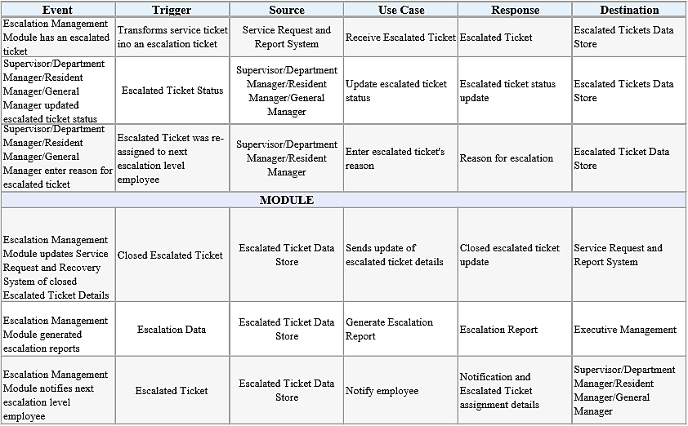 Escalation Management Module receives escalated tickets from the Service Request and Report System. The escalated tickets are service tickets are not closed within the given time limit. It is assumed that the client has a Ticket Manager which will be responsible for monitoring the tickets

Figure 1. Event Table

## Use Case

Figure 2. Use Case Diagram

Fully-Dressed Use Case

|  |  |  |
| --- | --- | --- |
| Use Case Name: | Transform service ticket into escalation ticket | |
| Scenario: | Service request and report system transforms service ticket into escalation ticket | |
| Triggering Event: | Service request and report system manually transform service ticket into escalation ticket | |
| Brief Description: | When service ticket has reach time limit, the service request and report system transform service tickets into escalated ticket | |
| Actors: | Service request and report system | |
| Related Use Case: | Includes: Unattended service ticket | |
| Stakeholders: | Service Request and Report System  Supervisor  Department Manager  Resident Manager  General Manager | |
| Preconditions: | Service ticket must exist  Service ticket must reach its time limit | |
| Postconditions: | Escalation Ticket must be created | |
| Flow of events: | Actor | Module |
| 1. Service request and report system creates service ticket 2. Service request and report system monitors service ticket 3. Service request and report system transforms service ticket to escalation ticket | * 1. Service ticket reach time limit   3.1 Stores escalation ticket details to database |
| Exception Conditions: |  | |

Table 2. Fully-Dressed Use Case 01

|  |  |  |
| --- | --- | --- |
| Use Case Name: | Update escalation ticket status | |
| Scenario: | Supervisor/Department Manager/Resident Manager/General Manager updates escalation ticket status | |
| Triggering Event: | Modify escalation ticket task status | |
| Brief Description: | When the module notifies employee the Supervisor /Department Manager/Resident Manager/General Manager will update escalation ticket status | |
| Actors: | Supervisor  Department Manager  Resident Manager  General Manager | |
| Related Use Case: | N/A | |
| Stakeholders: | Supervisor  Department Manager  Resident Manager  General Manager | |
| Preconditions: | The module must notify the next senior employee first | |
| Postconditions: | Escalation Ticket status must be updated | |
| Flow of events: | Actor | Module |
| 1.1 Supervisor/Department Manager/Resident Manager/General Manager views notification  2. Supervisor/Department  Manager/Resident Manager/General  Manager updates escalation ticket  status | 1. Notify employee  2.1 Stores updated escalation ticket status |
| Exception Conditions: |  | |

Table 3. Fully-Dressed Use Case 02

|  |  |  |
| --- | --- | --- |
| Use Case Name: | Reassign ticket to next escalation level | |
| Scenario: | Supervisor/Department Manager/Resident Manager/General Manager reassign ticket to next escalation level | |
| Triggering Event: | Current employee escalates ticket to next senior employee | |
| Brief Description: | When the module notifies the Supervisor/Department Manager/Resident Manager/General Manager will update escalation ticket status | |
| Actors: | Supervisor  Department Manager  Resident Manager  General Manager | |
| Related Use Case: | Includes: Enter escalation ticket’s reason | |
| Stakeholders: | Supervisor  Department Manager  Resident Manager  General Manager | |
| Preconditions: | Employee must enter escalation ticket’s reason | |
| Postconditions: | Escalation Ticket must be forwarded to the next escalation level | |
| Flow of events: | Actor | Module |
| 1.1. Supervisor/Department  Manager/Resident Manager/General  Manager views notification   1. Supervisor/Department   Manager/Resident Manager/General Manager enters escalation ticket’s reason   1. Supervisor/Department Manager/Resident Manager/General Manager reassign ticket to next escalation level | 1. Notify employee  2.1. Sends escalated ticket to next senior employee  4. Generates escalation report |
| Exception Conditions: |  | |

Table 4. Fully-Dressed Use Case 03

## Process Specification

### Context Flow Diagram

Figure 3. Context Flow Diagram

### Data Flow Diagram

Figure 4. Data Flow Diagram (Level 0)

Figure 5. Level 1 of Process 2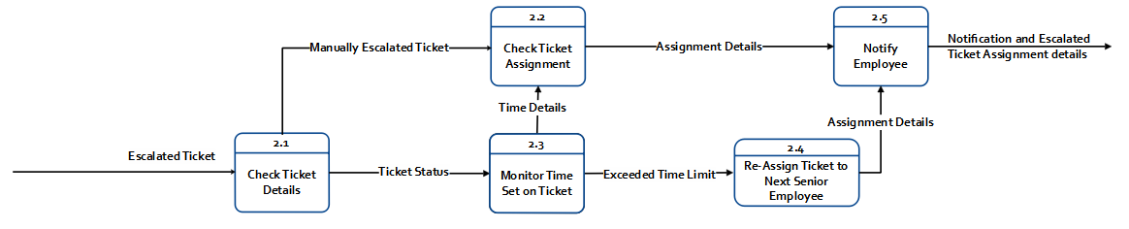

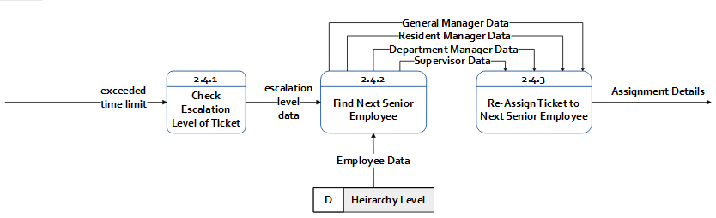

Figure 6. Level 2 of Process 2.4

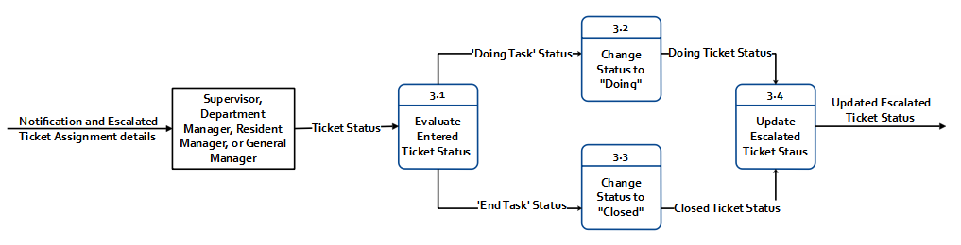

Figure 7. Level 1 of Process 3

Figure 8. Level 1 of Process 6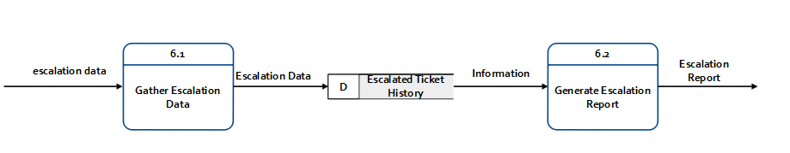

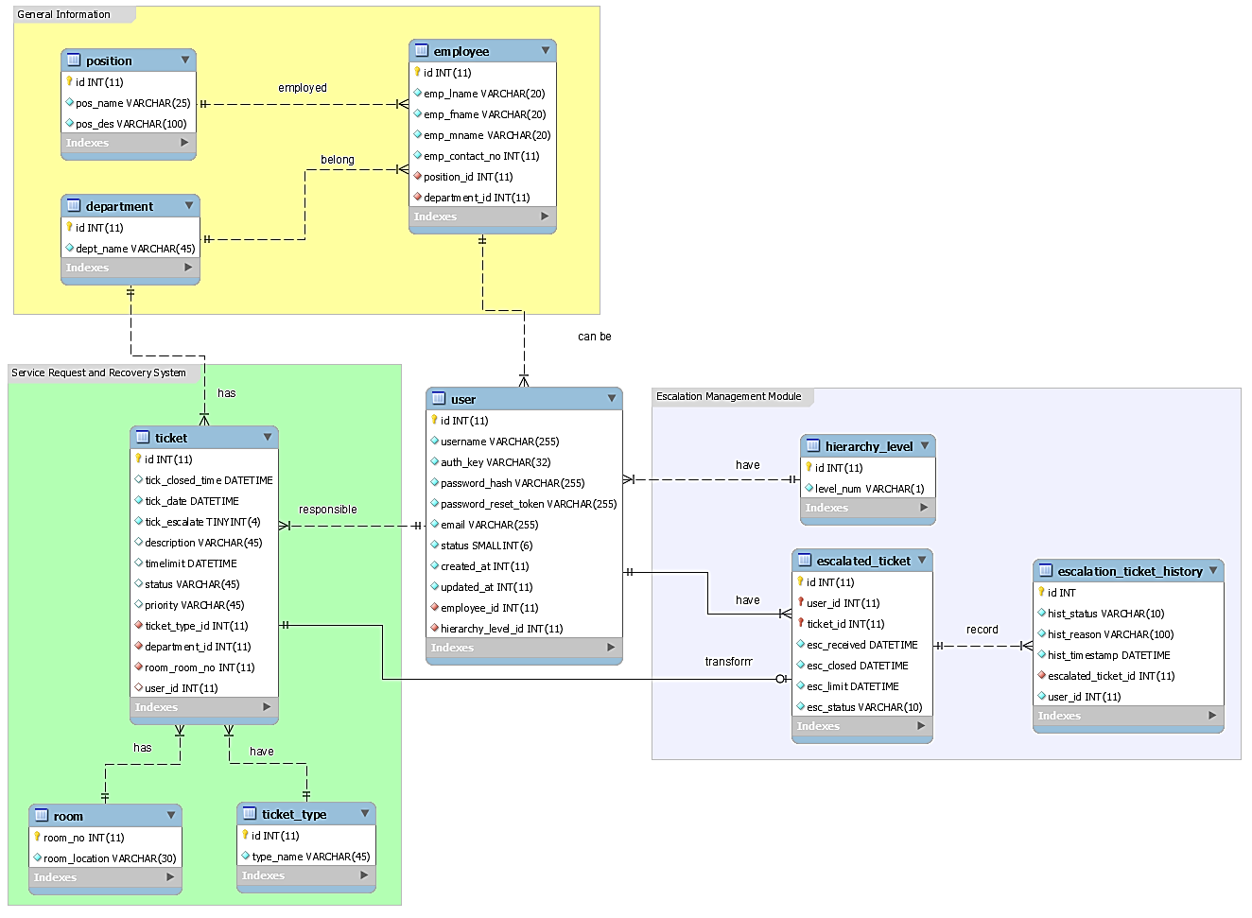

## Data Specification

### Entity Relationship Diagram

Figure 9. Entity Relationship Diagram (ERD)

### Data Dictionary

Figure 10. DD for Employee and Position Table

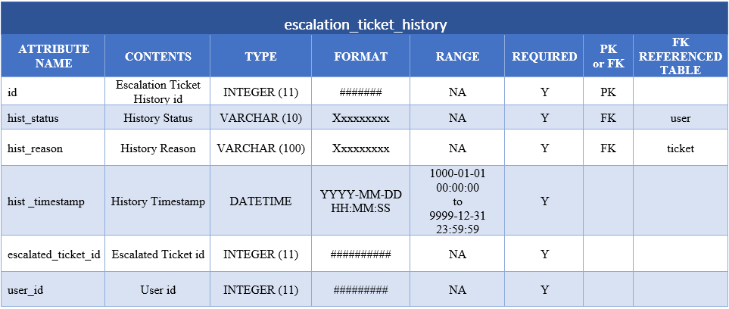

Figure 11. DD for Escalation Ticket History Table

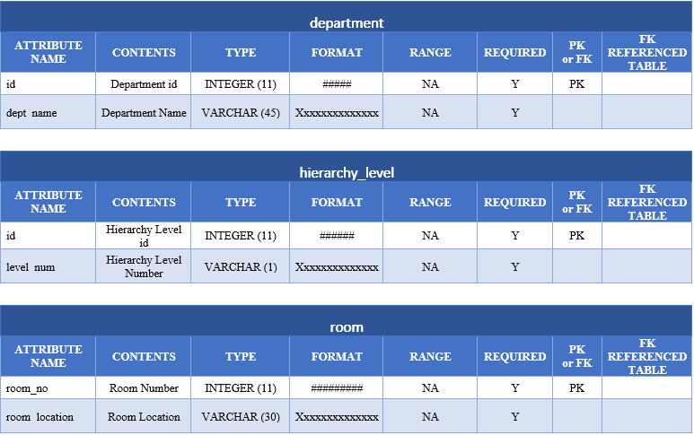Figure 12. Department; Hierarchy Level; Room

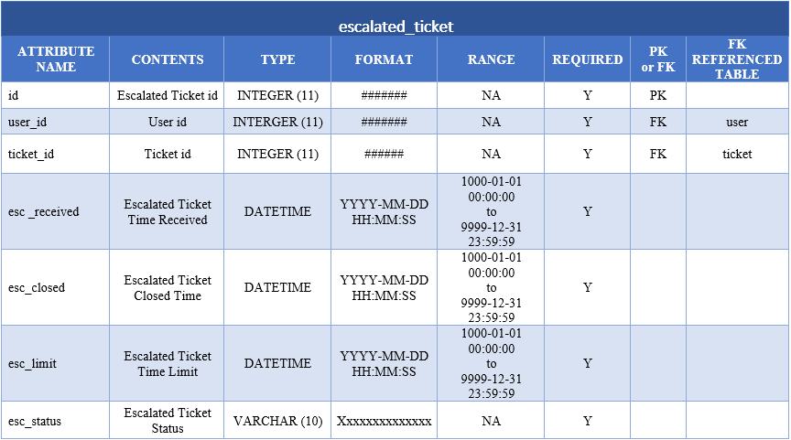

Figure 13. DD for Escalated Ticket

Figure 14. DD for User Table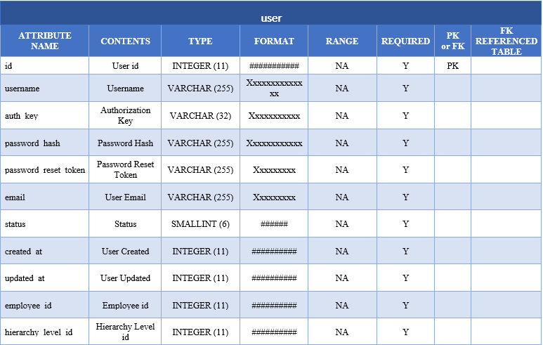

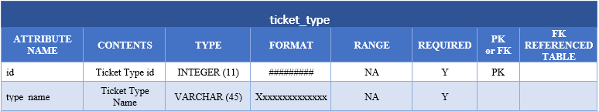

Figure 15. DD for Ticket Type

Figure 16. DD for Ticket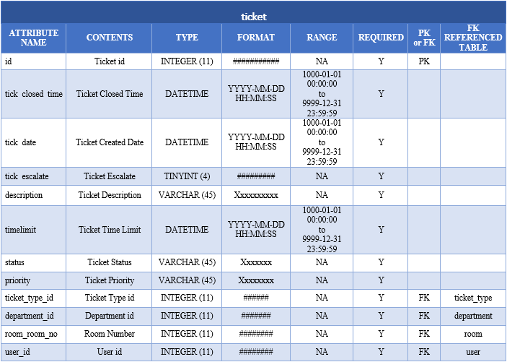

## Gap Analysis

|  |  |  |
| --- | --- | --- |
| **USER REQUIREMENTS** | **CURRENT SYSTEM** | **PROPOSED CHANGES** |
| 1. Gather escalation data | Issues are recorded by the Guest Service Center using Freshdesk and Excel. | Develop an escalation management module that automatically gathers all the escalation data entered in to the module. |
| 2. Improve escalation process | Limited escalation processes | Develop an escalation management module that will receive service tickets which are not closed within the given SLA and will be re-assigned to the senior level employees. |
| 3. Identify how services can be improved through an escalation process. | Limited escalation processes | The escalation management module can generate escalation reports that can be used by the Executive Management for decision making. |
| 4. Ease of notification via hand-held devices. | Staff and other employees communicates using walkie-talkies and telephones. | The escalation management module will be a mobile application that will be installed in a smart phone.  The employees assigned with escalation levels will be notified regarding escalated service requests. |

Table 5. Gap Analysis

## Methodology

* Agile Methodology

This is the methodology used to develop the Escalation Management Module for Taal Vista Hotel. Agile Methodology provides opportunities to assess the direction of the team’s project throughout the development lifecycle. For the team to present a partially working project for SYSADD, the team created a database which will define all the entities needed for the escalation module and next is to consolidate all the databases of the whole section to produce the master database and can have a back-end prototype which can Create, Read, Update and Delete Records with the use of Yii Framework. As for MCSPROJ, the first iteration is fifty percent (50%) of the prototype which was presented a week before the Midterm Defense. Second iteration is seventy percent (70%) on the day of the Midterm Defense. And the last iteration is on the Final Defense which will be a fully working Escalation Management Module.

## Other Graphical Representation

### Class Diagram

Figure 17. Class Diagram

### Object Diagram

Figure 18. Object Diagram

### Package Diagram

Figure 19. Package Diagram

### Activity Diagram

Figure 20. Activity for SRRS-HEMM-Senior Employee

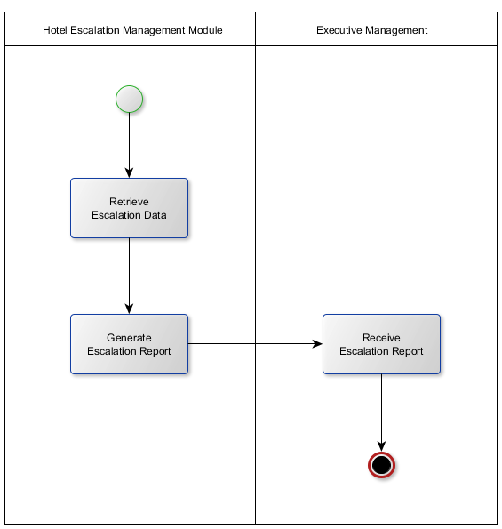Figure 21. Activity for HEMM and Executive Management

### State Machine Diagram

Figure 22. State Diagram

### Sequence Diagram

Figure 23. Sequence Diagram

### Communication Diagram

Figure 24. Communication Diagram

### Component Diagram

Figure 25. Component Diagram

### Deployment Diagram

Figure 26. Deployment Diagram

### Interaction Diagram

Figure 27. Interaction Diagram

# References

*Android, the world's most popular mobile platform | Android Developer* . (n.d.). Retrieved from Android Developers: https://developer.android.com/about/index.html

*FCS Connect Guest Service Managements* . (n.d.). Retrieved from FCS: https://www.fcscs.com/connect/

*GESS.pdf*. (n.d.). Retrieved from GESS.pdf: http://gess.ph/GESS.pdf

*GESS.pdf* . (n.d.).

*Hotel Staff Technology | ALICE Staff*. (n.d.). Retrieved from Alice: https://info.aliceapp.com/staff

*HOTELMGR-Brochure.pdf.* (n.d.). Retrieved from Microsoft Word-Hospitality-Solutions_EN_0.docx: http://www.mitel.com/sites/default/files/HotelMGR-Brochure.pdf

*HotelTap*. (n.d.). Retrieved from HotelTap: http://www.hoteltap.com/index.html

*KNOW Glitch* . (n.d.). Retrieved from KNOWCROSS: http://www.knowcross.com/know-glitch/

*Oracle Common Application Calendar User Guide .* (n.d.). Retrieved from Oracle Escalation Management Module : https://docs.oracle.com/cd/E18727_01/doc.121/e13407/T87077T87120.htm

Peter, M. (2014). Escalation Management as the Necessary Form of Incident. *Journal of Emerging Trends in Computing and Information Sciences*, 641.